CHALLENGE:
Goal of the Exercise
The goal of this exercise is to test your understanding of a Cloud Compute deployment with Terraform.
You are tasked with creating a codebase for a microservice deployment on a cloud environment, using Terraform. Since our focus is not the application itself, the service will be a simple web server that returns a static page.
Requirements::
Service Details
The service will be a simple web server that returns a static page.
You can use apache2 or nginx to serve a simple HTML file.
The service should be containerized and stored in a Docker registry.
The service should be deployed on a single VM instance as a docker container.
The image should be pulled from the registry specified earlier.
- The service should not be accessible from the internet but only through a Load Balancer, except for SSH access from specific IP addresses.
Deliverables
You are to provide the following as part of your solution:
- Dockerfile to build the image.
- Terraform codebase to deploy the following:
- Docker registry
- VPC and all required networking resources
- EC2 instance
- Load Balancer
Notes
Since a CI/CD pipeline is not part of this exercise, we will work around that with the help of Terraform.
To push the image to the Docker registry, build the image locally before running the Terraform code.
Once the image registry is created, use Terraform to push the local image to the registry.
Similarly, use Terraform to pull the image from the registry and run it on the VM instance once it is created.
For SSH access:
Use a locally created key.
Add it to the cloud provider key storage.
Attach it to the instance.
Use Terraform best practices for file structure and code organization.
Use variables, locals, modules, etc. when appropriate.
Include all tfvars, scripts, and other helper files used to deploy the application.
You may use any cloud provider of your choosing, although AWS is preferred.
- Use a free tier account or a trial account to deploy the resources.

Main Agenda of the Exercise
The primary agenda of this exercise is to assess the ability to design, deploy, and manage cloud infrastructure using Infrastructure as Code (IaC) principles, specifically with Terraform. The exercise focuses on implementing a secure and production-like microservice deployment rather than developing a complex application.
The simple web server serves only as a means to evaluate infrastructure design, automation, and cloud architecture knowledge.

Deployment Process (Git-based, Terraform-only)
This project deploys a containerized microservice on AWS using Terraform, where all application artifacts are sourced from a Git repository and no Docker build is performed locally.

1. Source Code Management (Git Repository)
The application source code is stored in a Git repository and includes:
- Dockerfile – defines the container image
- index.html – static web content served by the container
- Terraform configuration files – infrastructure as code
No application files or Docker artifacts are created manually on the local machine.
2. Infrastructure Provisioning with Terraform
Terraform is used as the single orchestration tool to provision all required AWS resources, including:
- VPC, subnets, routing, and internet access
- Security groups for the Application Load Balancer (ALB) and EC2 instance
- Amazon ECR repository to store the Docker image
- IAM role and instance profile with ECR push permissions
- EC2 instance to build and run the container
- Application Load Balancer, listener, target group, and health checks
Terraform is executed only from the local machine, but no Docker operations are performed locally.
3. EC2 Bootstrap via User Data (Git-Driven Build)
When Terraform launches the EC2 instance, it passes a user data script that automates the entire application lifecycle.
During the first boot, the EC2 instance performs the following steps automatically:
- Updates the operating system
- Installs required packages:
  - Docker
  - Git
  - AWS CLI
- Starts and enables the Docker service
- Authenticates Docker to Amazon ECR using the attached IAM role
- Clones the application source code from the Git repository
- Builds the Docker image using the Dockerfile from the repository
- Tags the image for the Amazon ECR repository
- Pushes the Docker image to Amazon ECR
- Runs the container from the image stored in ECR
All Docker build and push operations are executed on the EC2 instance, not on the local machine.

4. Container Runtime and Networking
- The Docker container listens on port 80 inside the EC2 instance.
- The EC2 instance is registered as a target in an ALB target group.
- The Application Load Balancer performs health checks on the container endpoint.
- Only the ALB is publicly accessible.
- The EC2 instance is not directly exposed to the internet (except restricted SSH access for administration).

5. Application Access
Once the container becomes healthy, the application is accessible via the ALB DNS name:
http://<application-load-balancer-dns-name>
The load balancer routes incoming HTTP requests to the EC2 instance, which serves the static web page from the running Docker container.

6. Key Design Principles
- Terraform-only orchestration: Terraform controls the entire workflow.
- Git-based artifacts: All application files are sourced from Git.
- No local Docker dependency: Docker is not required on the local machine.
- Immutable image workflow: Images are built once and stored in a registry.
- Secure access model: The service is accessible only through the load balancer.
7. End-to-End Flow Summary
Git Repository
↓
Terraform provisions AWS infrastructure
↓
EC2 instance boots and runs user data
↓
EC2 clones Git repo
↓
EC2 builds Docker image
↓
EC2 pushes image to Amazon ECR
↓
EC2 runs container
↓
Application Load Balancer routes traffic
8. Outcome
This approach ensures a fully automated, reproducible deployment where infrastructure and application delivery are tightly integrated using Terraform, without relying on any local Docker setup.

1. Objective
The objective is to deploy a containerized microservice on AWS using Terraform, where:
- The service serves a static HTML page
- The application runs inside a Docker container
- The container image is stored in AWS ECR
- The container runs on a single EC2 instance
- Traffic reaches the service only through a Load Balancer
- Direct internet access to the instance is blocked
- SSH access is restricted to specific IP addresses
- Terraform manages everything:
  - Networking
  - Registry
  - Compute
  - Load balancer
  - Image push & pull
  - Instance bootstrapping
This tests:
- Infrastructure as Code
- Networking & security fundamentals
- Docker + registry workflow
- Terraform best practices

2. High-Level Architecture
Internet
↓
Application Load Balancer (public)
↓
Target Group
↓
EC2 Instance (private subnet)
↓
Docker container (nginx serving static HTML)

Security model
- ALB: publicly accessible
- EC2: no public IP
- Security Groups:
  - ALB → EC2 on port 80
  - SSH → EC2 only from allowed IPs

3. Repository Structure (Terraform Best Practices)
.
├── docker/
│ ├── Dockerfile
│ └── index.html
│
├── terraform/
│ ├── main.tf
│ ├── variables.tf
│ ├── outputs.tf
│ ├── provider.tf
│ ├── vpc.tf
│ ├── terraform.tfvars
│ ├── ecr.tf
│ ├──ec2.tf
│ ├──alb.tf
│ ├──iam.tf
│ ├── security.tf
│ ├── user_data.sh
│
└── README.md

4. All the syntax and tf files will be available on my git hub
https://github.com/attalurisaiteja/Docker-Final-Task.git
Clone the repo and execute the task
Note: changes in files are
- Region
- Ami id
- Instance type
- Keyname
- Github link
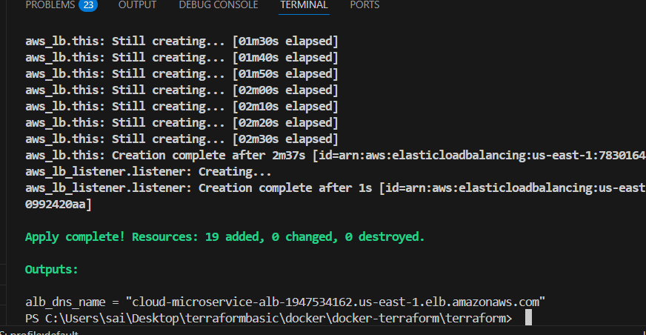
Successfully verified on browser using alb
